Task – 19 Terraform task
Created main, variable and outputs file
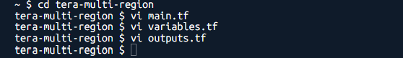
Instance created on Mumbai region but as GUVI doesn’t support Singapore region not able to create another EC2

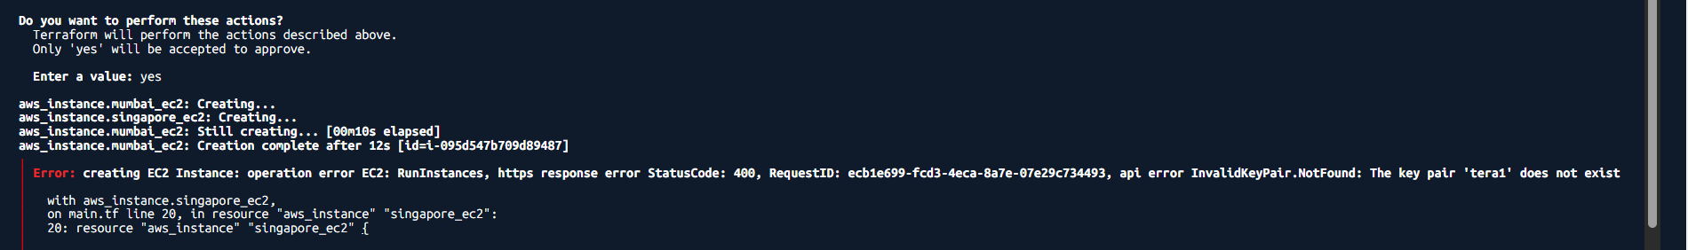

Server created via terraform in Mumbai region
